Instructions:

* Please no talking during the exam
* This is an open-book exam, you can use the Internet, notes, book, and or lab materials on Canvas.
* Quiz #1 must be submitted before 9:20 pm.

**There are 7 projects, each is worth 14.2%.**

**Project #1 (IF STATEMENT)**

Suppose you have a program that determines the price of a product based on its quantity. If the quantity is less than 10, the price per item is $5. If the quantity is between 10 and 50 (inclusive), the price per item is $4. For quantities greater than 50, the price per item is $3. Write a Python program using multiple if statements to calculate the total price for a given quantity. Ask the user to input the quantity.

**#1 Print screen the output with the code below here.**

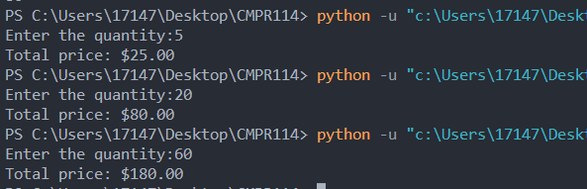

Code:

qty = int(input("Enter the quantity:"))

price = 0

if qty < 10:

price = qty*5

elif qty<51:

price = qty*4

else:

price = qty*3

print(f"Total price: ${price:,.2f}")

**Project #2 (based on Chapter 02)**

Create a program that will ask the user to enter the gross salary (input $80,000.00) as the test data, and then add 10% to the gross salary. Format the output with dollar signs, commas, and periods as shown below.

The expected outcome is $88,000.00.

**#2 Print screen the output with the code below here.**

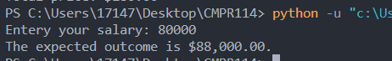

Code:

salary = int(input("Entery your salary: "))

total = salary + (salary*.1)

print(f"The expected outcome is ${total:,.2f}.")

**Project #3 (based on Chapter 02)**

Create a program that will ask the user to enter 5 scores (use 60, 70, 80, 90) then sum the scores, and then average the scores as well.

Expected outcomes is sum = 300, average = 75

**#3 Print screen the output with the code below here.**

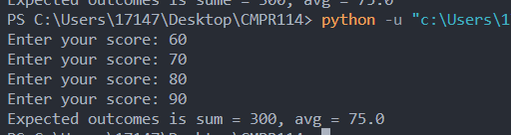

Code:

totalscore = 0

for i in range(4):

score = int(input("Enter your score: "))

totalscore += score

avg = totalscore/4

print(f"Expected outcomes is sum = {totalscore}, avg = {avg}")

**Project #4 (based on Chapter 03)**

Create a program that will ask the user to enter the Sales, and then display the commission. See table below: Use the If statement.

|  |  |
| --- | --- |
| **In sales** | **Commission** |
| $50,000.00 - $60,000.00 | 10% |
| $70,000.00 - $80,000.00 | 20% |
| $90,000.00 - $100,000.00 | 30% |

**#4 Print screen the output with all possible commissions below here with the code.**

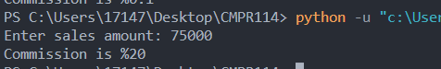

Code:

salesamt = int(input("Enter sales amount: "))

if salesamt >=50000 and salesamt <= 60000:

commission = 10

elif salesamt >=70000 and salesamt <= 80000:

commission = 20

elif salesamt >=90000 and salesamt <= 100000:

commission = 30

print(f"Commission is %{commission}")

**Project #5 (based on Chapter 04)**

Create a program that will ask the user to enter a grade score (4 scores) and output the letter grade associated with the average grade. *Then using a* ***while*** *loop, if the average is greater than 100, inform the user to re-enter the 4 scores.*

|  |  |
| --- | --- |
| If the average is between 90-100 | Then receive a letter grade of (A) |
| 80-89 | B |
| 70-79 | C |
| 60-69 | D |
| Below 60 | F |

**#5 Print screen the average for a letter grade (A) below here.**

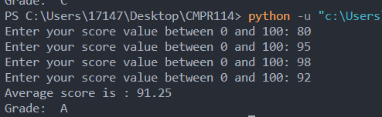

**#5 Print screen when the average is greater than 100 below here.**

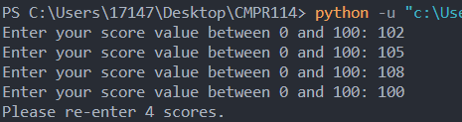

**#5 Print screen your entire code below here.**

Code:

cnt = 1

totalscore = 0

score = 0

while cnt < 5:

score = int(input("Enter your score value between 0 and 100: "))

totalscore += score

cnt += 1

avgscore = totalscore / 4

if avgscore > 100:

print("Please re-enter 4 scores.")

else:

if avgscore >= 90:

grade = "A"

elif avgscore >= 80:

grade = "B"

elif avgscore >= 70:

grade = "C"

elif avgscore >= 60:

grade = "D"

else:

grade = "F"

print(f'Average score is : {avgscore:.2f}')

print(f"Grade: {grade}")

**Project #6 (based on Chapter 5 functions) for the** **program below be sure to use functions.**

***Be sure to SUM or total the calories from fat and carbs and print the results in the console. ***

**#6 Print screen the output with the code below here.**

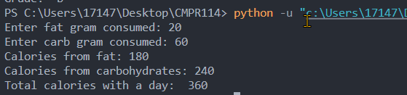

Code:

fat_intake = int(input("Enter fat gram consumed: "))

carb_intake = int(input("Enter carb gram consumed: "))

calories_fat = fat_intake* 9

calories_carb = carb_intake* 4

total = calories_fat + calories_fat

print(f"Calories from fat: {calories_fat}")

print(f"Calories from carbohydrates: {calories_carb}")

print(f"Total calories with a day: {total}")

**Project #7 (based on Chapter 6 Files and Exceptions)**

Write a program that will **read** the coffee text file (please download from module 3). Display the entire file on the console.

**#7 Print screen the output with the code below here.**

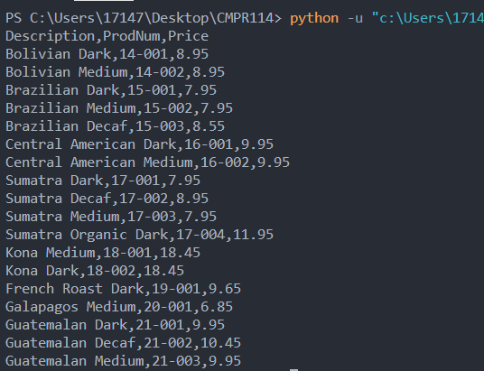

Code:

file = open("C:\\Users\\17147\\Desktop\\CMPR114\\m3\\Coffee.txt", "r")

content = file.read()

print(content)

**Submit this document to the module 3 quiz.**